**Disambiguation as a domain-general strategy:**

**Faces-to-voices, animal vocalizations-to-animals, and gestures-to-objects**

Symposium Chairs: Ricardo Bion and Larissa Samuelson

When young children are presented with a novel object and a familiar object as they hear a novel name, they tend to select the novel object. This disambiguation bias is often assumed to reflect children’s expectations about the nature of words or expectations about the communicative intention of speakers. The new studies presented in this symposium propose several different challenges to these assumptions. Taken together, they provide evidence that young children use reasoning by exclusion in non- linguistic as well as non-communicative contexts, while failing to use this strategy in contexts that closely parallel the pragmatics of word learning tasks. The first talk shows that children look more at unfamiliar faces when hearing unfamiliar voices in the presence of both familiar and unfamiliar faces. The second talk reports that children look more at unfamiliar animals when hearing novel animal vocalizations in the presence of both familiar and unfamiliar animals. The third talk shows that despite mapping novel words to novel objects, children surprisingly map novel gestures to familiar objects instead. The discussant will integrate and reconcile these findings within a computational framework, showing how disambiguation biases emerge within domains as long as there is competition between stimuli and consistent mappings over time. Using different paradigms (offline and online experimental measures, computational modeling) to examine a diverse array of mappings (words-to-objects, faces-to-voices, animal vocalizations-to-animals, and gestures-to-objects) these studies demonstrate that disambiguation biases are not restricted to linguistic and communicative contexts and instead reflect domain-general strategies based on children’s already existing knowledge.

**2:20 – 2:25 - *Introduction***

Larissa Samuelson

**2:25 – 2:40 - *Reasoning by exclusion: faces & voices and searching for objects***

Justin Halberda

**2:45 - 3:00 - *One-to-one biases in a non-linguistic and non-communicative domain: 30-month-olds map novel animal vocalizations to unfamiliar animals***

Ricardo Bion, Kyle MacDonald, and Anne Fernald

**3:05 - 3:20 - *Young children's disambiguation of words and symbolic gestures: Implications for domain-specificity***

Sumarga Suanda and Laura L. Namy

**3:25 - 3:35 - *Discussion***

Larissa Samuelson

**3:35 - 3:50 - *Audience Discussion***

**Reasoning by exclusion: faces & voices and searching for objects**

Justin Halberda

Reasoning by exclusion requires a child to use what they currently know in order to eliminate possibilities and to construct new knowledge. Much emphasis has been given to how this kind of reasoning might help young children determine the referents of novel words in ambiguous contexts. Here, we demonstrate that children use similar reasoning to learn about new faces and voices and to determine the hidden location of familiar objects. Children’s pointing and looking behavior showed that they are able to reason by exclusion across different domains.

In three experiments using a preferential looking procedure, participants were seated at a table and presented with two or more objects on each trial. After a measure of baseline looking preference, children were asked to find the target item. On critical trials, children could infer the target through reasoning by exclusion. We first aimed at replicating previous findings in the literature showing that children could infer that a new label must go with a novel object (i.e., “this object is called a ‘ball’, so that strange object there must be the ‘dax’”). We then asked whether children could use similar strategies to map information about what someone looks like to information about what this person sounds like. When pictures of two faces were presented – one person that the child knew and one new person – and children heard a new voice speaking, they could infer that the new voice must belong to the new face because each person has only one voice (i.e., “that is not Charlie’s voice I’m hearing, so it must be this new person who is talking”). We finally asked whether children could use reasoning by exclusion in a task with only familiar labels and objects, contrasting with the canonical referent- selection tasks involving novel words and objects. A new group of children were presented with an opaque hiding box that they knew held a particular animal (e.g., bear) and a second opaque hiding box they had not seen before and they were asked to find an animal they hadn’t seen before (e.g., “can you find dog”). Children could reason via process-of-elimination to infer that the new animal (e.g., dog) must be in the new box (i.e., “the dog can’t be in this box because I know that bear is already in there and dog wouldn’t fit, so dog must be hiding in this new box”).

In each experiment, participants’ fixation times to both targets and distractors and their reaction times to change fixation were coded frame-by-frame from videotape. Both reaction time data and the course of looking throughout each trial revealed a pattern consistent with reasoning by exclusion. When asked to e.g., “point at the dax,” participants systematically searched and rejected familiar object distractors before deciding to map the novel label “dax” to the novel object. Likewise for mapping faces to voices and finding hidden animals. The pattern of looking in each task was parametrically similar suggesting that, for preschoolers, reasoning by exclusion is a domain general learning strategy.

**One-to-one biases in a non-linguistic and non-communicative domain:**

**30-month-olds map novel animal vocalizations to unfamiliar animals**

Ricardo A. H. Bion, Kyle MacDonald, Anne Fernald

The disambiguation bias in referent selection has been characterized in various ways - as motivated by lexical-specific constraints or principles (Markman, 1991; Mervis & Bertrand, 1994), by pragmatic inferences about speakers’ communicative intentions (Clark, 1990; Diesendruk & Markson, 2001), or by domain-general learning mechanisms that favor simpler hypotheses in complex learning tasks (McMurray et al., in press). Lexical-specific accounts predict that one-to-one biases are unique to word learning, pragmatic accounts predict that they generalize to communicative acts more broadly, and domain- general accounts predict that they apply to any domain in which consistent one-to-one mappings are observed. To explore the domain-general account, this study investigated whether children show one-to-one biases in a domain that is non-linguistic and non-communicative for them, but in which consistent regularities between sounds and objects can be found: the vocalizations that animals produce.

First we asked how quickly 30-month-olds (n=19) are able to use three different acoustic cues in real-time identification of a familiar target animal. Using the looking-while-listening procedure, we measured children’s mean reaction time to orient to familiar target animals in response to three types of auditory stimuli: the animal name (e.g., dog), the lexicalized animal sound (e.g. woof-woof), and the natural animal vocalization (e.g., dog barking). On 32 trials, children saw pictures of two familiar animals on a screen (e.g., dog and cat) and heard one of the three sounds associated with the target animal (see Figure 1A). Figure 2A shows the time course of children’s orienting to the target over a 1500 ms window from sound onset. Children were significantly faster to orient to the correct animal in response to animal names (M=601 ms) than to natural animal vocalizations (M= 748 ms). These differences in mean RT can be explained both by differences in signal characteristics (e.g., higher information density at signal onset for words than natural animal sounds), and by massive differences in frequency of exposure between animal names and animal vocalizations.

Next we asked whether children showed one-to-one biases for animal vocalizations similar to biases in word learning. On 14 trials children saw pictures of a familiar and a novel animal (see Figure 1B). On disambiguation trials in the critical condition, children heard either a novel animal name (e.g., nadu) or a novel animal vocalization (e.g., gorilla vocalization). 30-month-olds looked reliably to the familiar animal when hearing the familiar animal name or vocalization, and also looked equally reliably to the novel animal when hearing the novel animal name or vocalization. This is the earliest age at which one-to-one biases have been observed in a domain other than word learning. Crucially, our results cannot be easily explained by pragmatic or lexical-constraints accounts, and seem to favor a domain-general learning mechanism that seeks simple regularities in complex learning tasks.

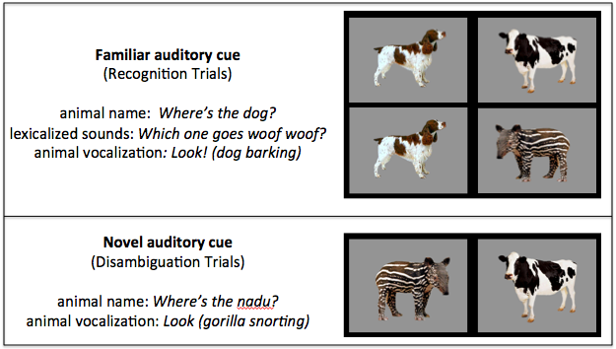

B

A

**Figure 1.** Trials organized by type of auditory cue. The target animal for each trial type is on the left and the distractor is on the right. (A) On Familiar Animal Recognition trials, children heard a familiar auditory cue in the presence of either two familiar or a familiar and a novel animal. (B) On Novel Animal Disambiguation trials, children heard either a novel animal name or a novel animal vocalization in the presence of a familiar and novel animal.

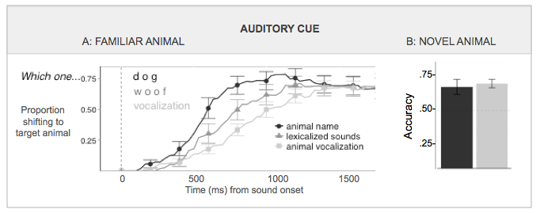

**Figure 2.** (A) **Familiar animal trials**: On trials when two familiar animals were shown, children were fastest to orient to the target animal in response to the animal name, and slowest in response to the natural animal vocalization. (B) **Disambiguation trials:** On trials when a novel animal was paired with a familiar animal, children were significantly above chance and equally accurate in choosing the novel animal in response to a novel animal name and novel animal vocalization, assessed over a 4500 ms window from target sound onset)

**Young children's disambiguation of words and symbolic gestures:**

**Implications for domain-specificity**

Sumarga Suanda and Laura L. Namy

One well-documented strategy children employ to determine the referent of new words is disambiguation: children avoid mapping new words onto objects for which they already have labels, in favor of mapping words onto objects for which they do not yet have labels (Markman & Wachtel, 1988). Although the behavioral pattern of disambiguation is uncontroversial, its underlying mechanism is a matter of debate. In the proposed paper, we will present two experiments that shed light on the nature of disambiguation by asking whether children exhibit disambiguation not only in the verbal domain, but also in the symbolic gesture domain, a domain in which many word learning phenomena generalize early in language acquisition (e.g., Namy & Waxman, 1998).

In Experiment 1, 18-month-old infants (N= 32) viewed pairs of objects that included one familiar (e.g., spoon) and one novel object (e.g., a garlic press). In target trials, an experimenter asked children to select the referent of a novel symbol (either word or symbolic gesture, depending on condition). Infants also completed preference control trials.

As expected, infants in the word condition selected novel objects more often in target trials (M= .61) than control trials (.46), and also more often than predicted by chance (.50). In contrast, infants in the gesture condition selected novel objects less often in target trials (.40) than in control trials (.54), and less often than predicted by chance (see Figure 1). This outcome indicates that infants reliably mapped novel gestures to familiar rather than novel objects. Disambiguation of novel words was positively correlated with productive verbal vocabularies, r = .57, p < .05. Disambiguation of novel gestures was not correlated with verbal vocabularies, r = .29, p >.10

In Experiment 2, 18-month-olds (N= 32) viewed pairs of novel objects. Infants first learned a novel label (either word or gesture) for one object and then completed the disambiguation task, selecting the referent of a second novel label from the same modality as the first novel label.

As expected, infants in the word condition selected unlabeled objects more often in target trials (.63) than control trials (.46) and more often than predicted by chance. Infants in the gesture condition selected unlabeled objects less often in target trials (.44) than control trials (.59) but did not differ from chance responding (see Figure 2). Verbal disambiguation was positively correlated with verbal vocabulary levels, r = .54, p < .05, but gestural disambiguation was not, r = -23, p >.10.

Across the two experiments, 18-month-olds reliably mapped novel words onto novel objects or unlabeled objects. In contrast, infants mapped novel gestures onto familiar or previously labeled objects. Although these data are consistent with a domain-specific account of disambiguation, that verbal disambiguation was positively correlated with verbal vocabularies suggests a role for experience in disambiguation. Thus, disambiguation may be better described as a general mechanism that emerges in specific domains as a function of experience within those domains.

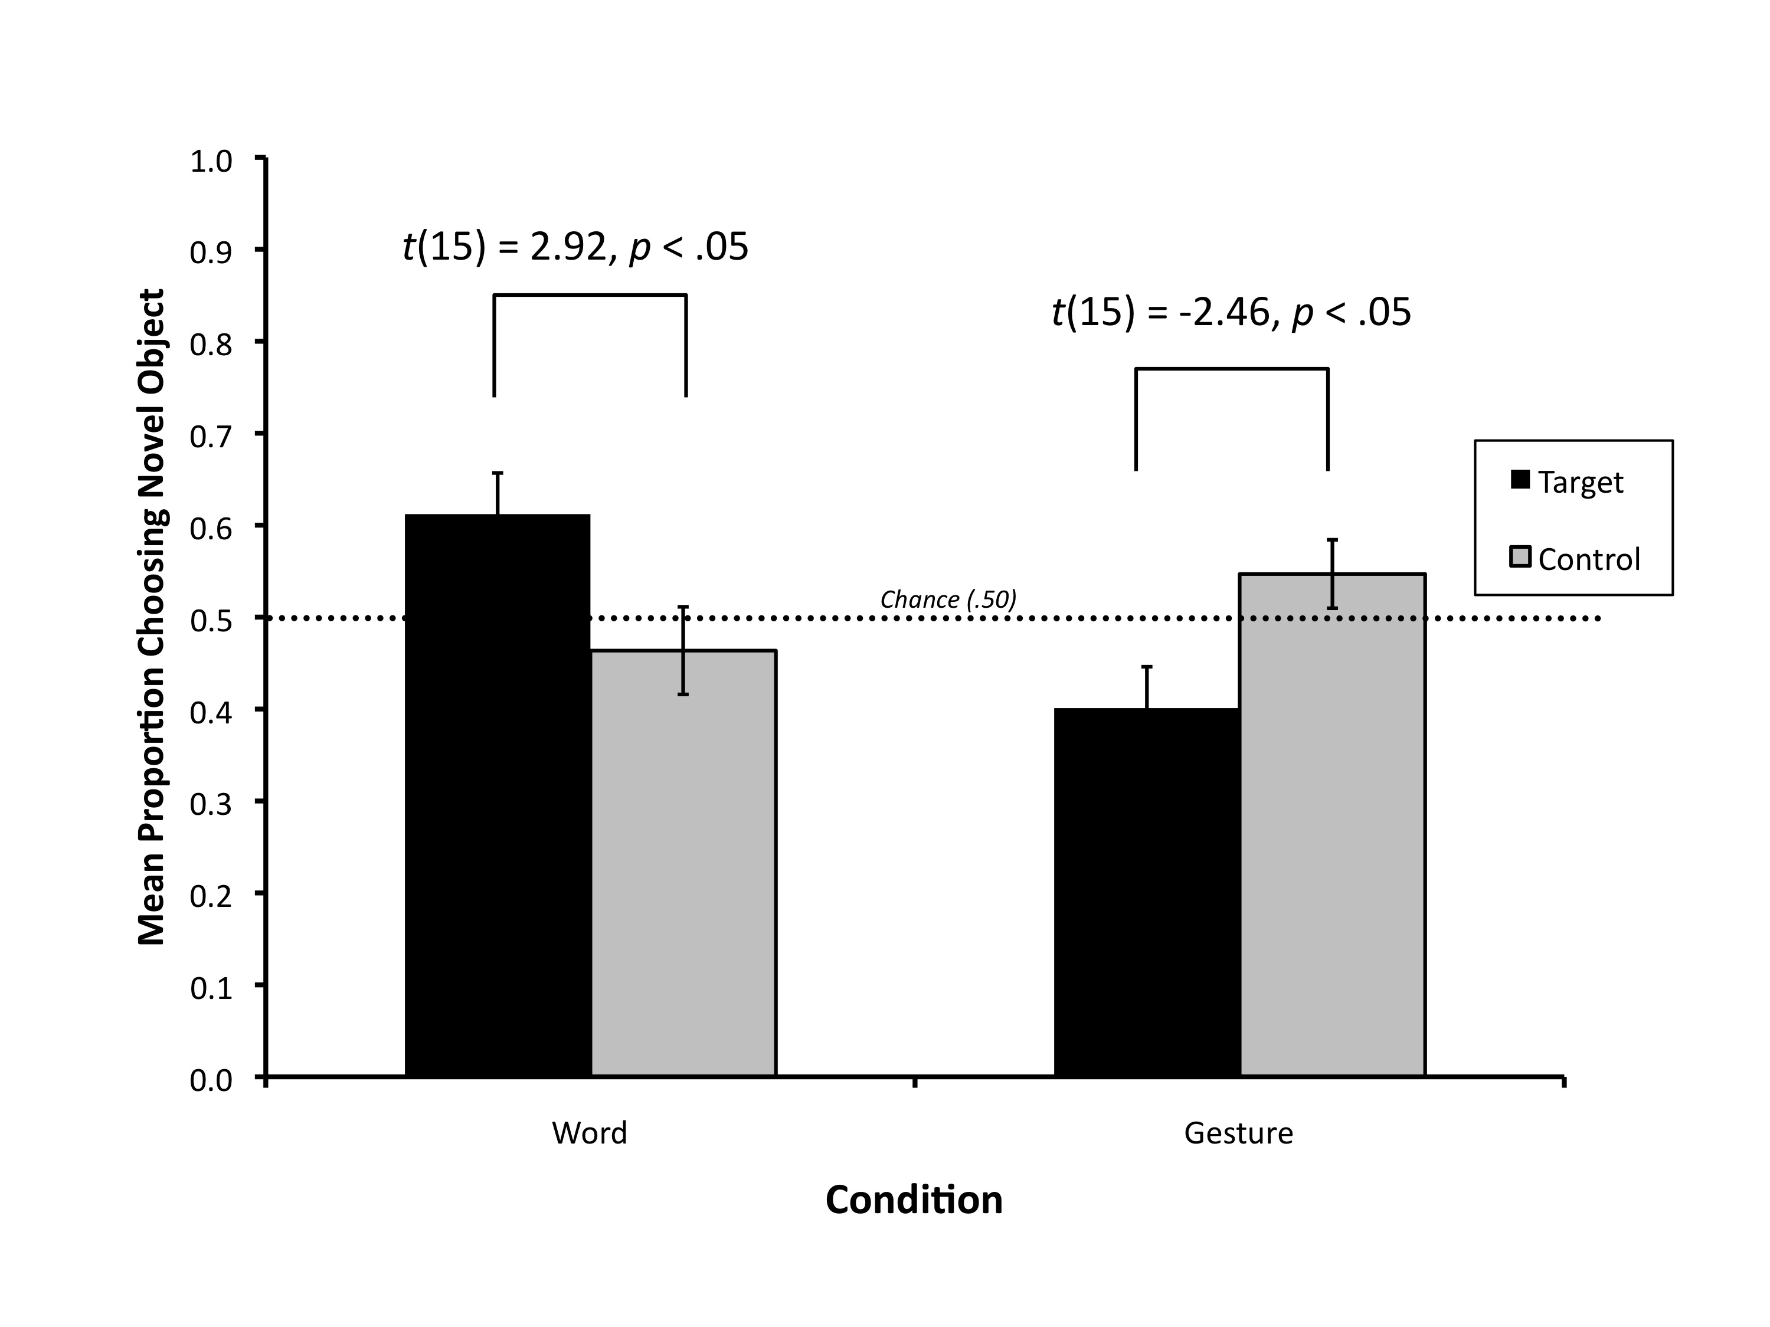

**Figure 1.** Mean proportion choosing novel object as a function of trial type and condition (n = 16 per condition)

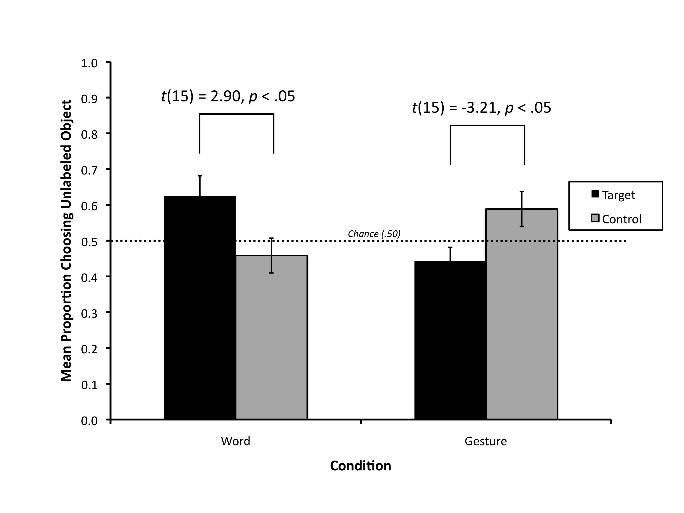

**Figure 2.** Mean proportion choosing unlabeled object as a function of trial type and condition (n = 16 per condition)